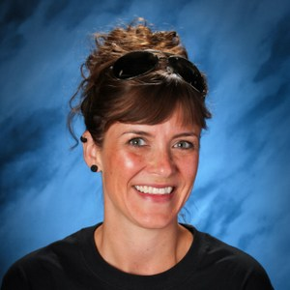
Sara Leonetti
English Teacher
Cheney High School, Cheney School District
sleonetti@cheneysd.org

I graduated from University of Idaho in May 2001 double-majoring in English Literature and Secondary Education with a minor in Spanish. After a year spent substitute teaching, I began my MA in Teaching English as a Second Language at Eastern Washington University. A year into the program, I began my first teaching job in Eagle, ID, completing my MA while working in 2004. With a desire to be closer to home, I taught for the next nine years in Post Falls High School, teaching English to every grade level, 9-12, and developing a Creative Writing program. Then, I moved to Cheney High School, and taught Spanish I, Language Arts 11, and now AP Literature. I currently serve on the TPEP, Mentor Teacher, and Highly Capable committees.

