Your annotations should attend to all three levels of thinking as listed below:
All of my annotations are:
1. Legible
2. Understandable to my future self and to my teacher
Level 1 | Level 2 | Level 3
Literal—found directly in the text | Interpretive/Analytical—found by making inferences | Universal/Thematic—found outside of the text
Questions/notes that check for understanding | Questions/notes about the author’s choices | Questions/notes about how the text relates to the world outside the text, including how it relates to my life and what I know.
L1 Annotations…  - are factual  - identify main points/events in the text  - lead to an accurate and thorough summary of the text | L2 Annotations…  - are inferential  - speculate about motive/purpose of author  - follow patterns and identify relationships among parts of the text | L3 Annotations…  - are reflective  - link text to prior knowledge, other texts, or personal experiences

EXAMPLE ANNOTATIONS FOR EACH LEVEL:
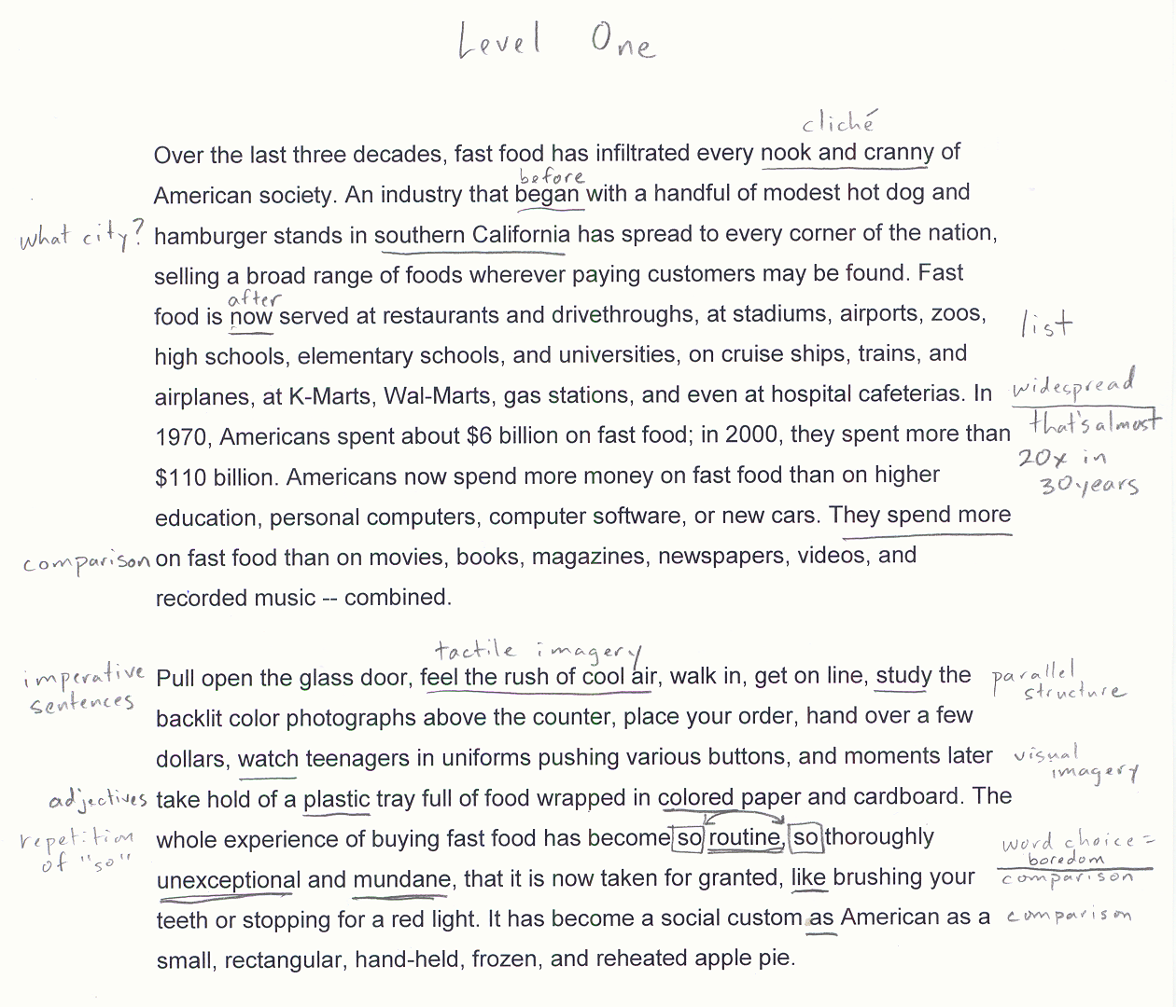

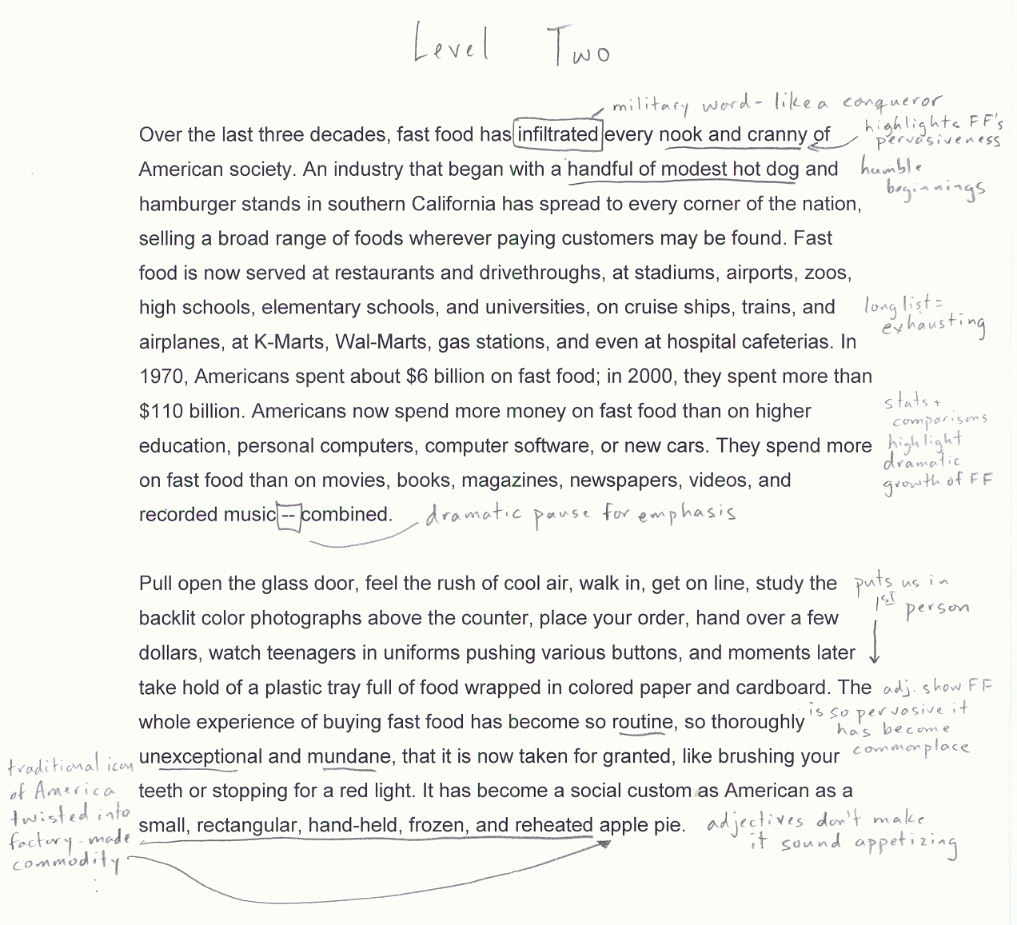

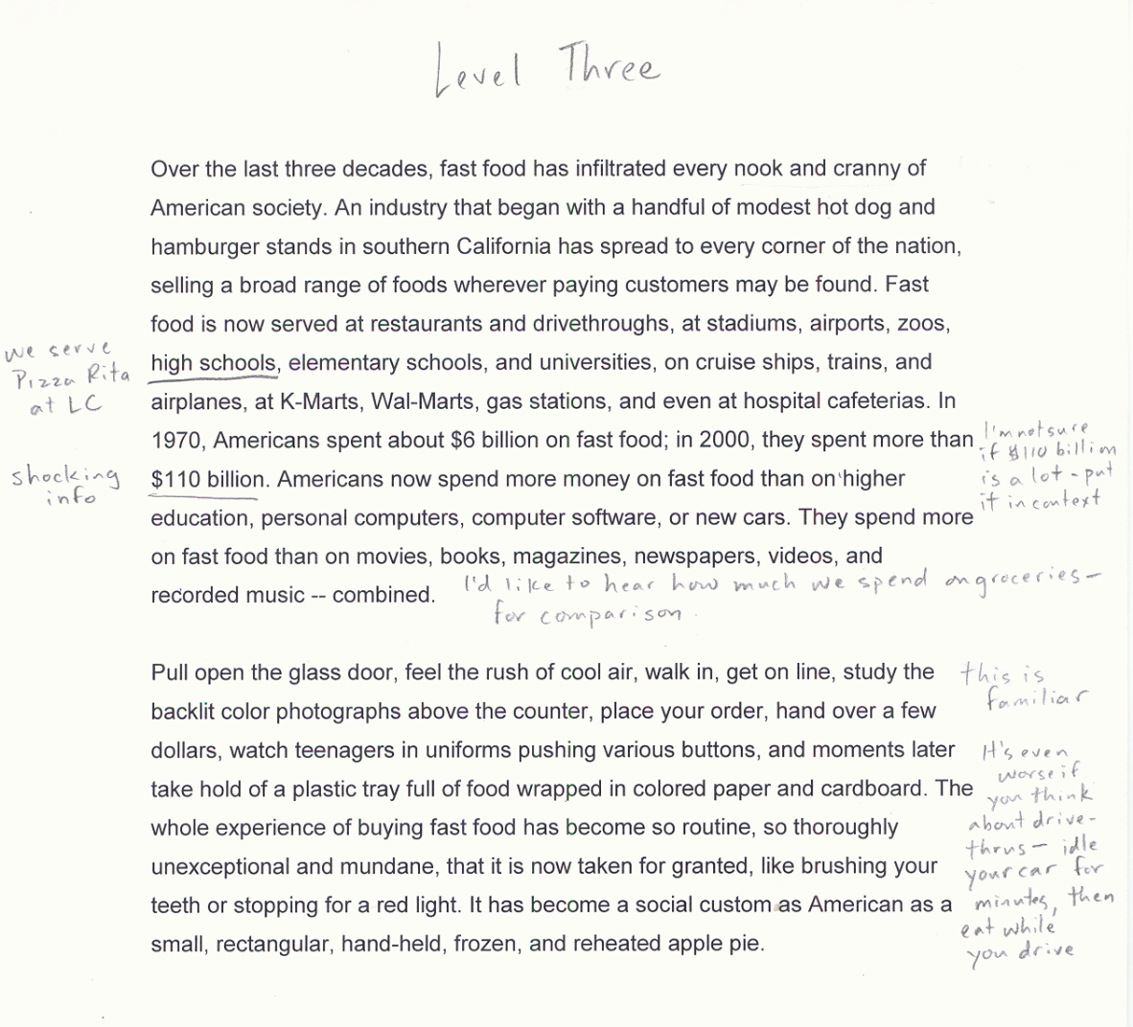

Summer Reading Annotations Rubric for the scope of the text
(based on the 9-point Advanced Placement College Board Scoring Scale)
1-2 Below standard, Unsuccessful | 3-4 Approaching standard, Inadequate | 5 | 6-7 Adequate, meets standard | 8-9  Effective
The student annotates too few sections of the text and/or the annotations are ILLEGIBLE.  The meanings of the student’s annotations are not clear to the reader.  - The student’s notes do not show understanding of the text in a way that is clear to the reader  - The students notes are limited to highlighting without annotating the highlights  - The student’s annotations are limited to personal responses | The student LEGIBLY annotates some of the scope of the text though some lapses in legibility may occur.  The student’s annotations are sometimes difficult for a reader to understand what he/she thinking as he/she read.  - The student’s annotations are limited to personal responses or paraphrase more than analysis  - The student does not note some obvious strategies used by the writer.  - The student does not attend to main points/claims over the scope of the whole work.  - Student does not identify some obvious figurative language/rhetorical strategies at work in the passage. | Inconsistent | The student LEGIBLY annotates the majority of the scope of the text on a variety of levels.  The annotations make clear to the reader what the writer was thinking as he/she read:  The annotations attend to a variety of levels of thinking. For instance, the student:  Level one:  - defines unknown vocabulary  - notes important main points/claims over the scope of the whole work.  - notes tone/connotatively charged diction  - identifies most of the figurative language/rhetorical strategies in the passages  - comments on the form/format/structure and shifts in style/structure  - determines point of view  - lists character traits  Level two:  - identifies the function of language/rhetorical strategies in the passages  - identifies the function of the style/structure  - makes inferences  - makes predictions and hypotheses  - notes patterns/motifs  - evaluates the author/character’s arguments/claims and may challenge these claims  Level 3:  - notes personal responses/emotional connections  - asks questions and theorizes answers  - makes connections outside of the text  - notes universal human behaviors, themes | The student LEGIBLY annotates and identities all of the items listed in the 6-7 category with clear, thorough insight and apt observations.  - All of the annotations are easily interpreted by the reader.  - The student pays particular attention to analyzing the function of figurative/rhetorical strategies at work in the passage.  - The student recognizes patterns and identifies complicated themes at work in the text

